**Hive 6.2 Assignment:**

**Problem Statement :1**

Fetch date and temperature from temperature_data where zip code is greater than 300000 and less than 399999.

Ans:

select tdate ,zipcode,temp from temperature where zipcode >= 300000 AND zipcode <= 399999;

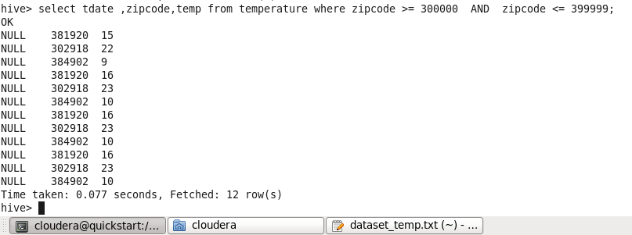

**Problem Statement :2**

Calculate maximum temperature corresponding to every year from temperature table.

Ans:

select YEAR(cast(to_date(from_unixtime(unix_timestamp(tdate, 'dd-MM-yyyy'))) as date)) Temp_date ,MAX(temp) from temperature

GROUP BY YEAR(cast(to_date(from_unixtime(unix_timestamp(tdate, 'dd-MM-yyyy'))) as date));

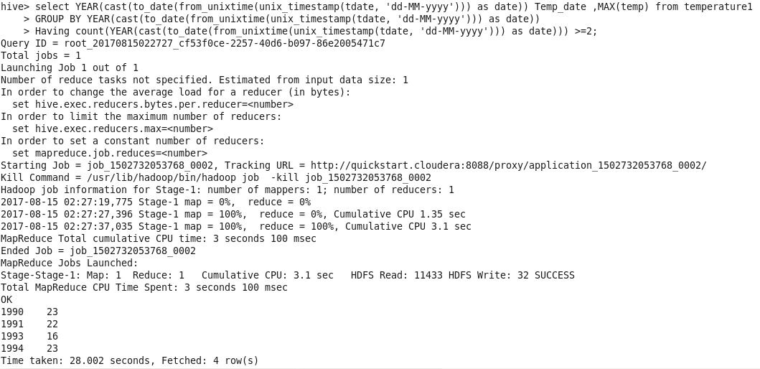

**Problem Statement :3**

Calculate maximum temperature from temperature table corresponding to those years which have at least 2 entries in the table

Ans:

SELECT YEAR(cast(to_date(from_unixtime(unix_timestamp(tdate, 'dd-MM-yyyy'))) as date)) Temp_date ,MAX(temp),

COUNT(YEAR(cast(to_date(from_unixtime(unix_timestamp(tdate, 'dd-MM-yyyy'))) as date)))

FROM temperature

GROUP BY YEAR(cast(to_date(from_unixtime(unix_timestamp(tdate, 'dd-MM-yyyy'))) as date))

Having COUNT(YEAR(cast(to_date(from_unixtime(unix_timestamp(tdate, 'dd-MM-yyyy'))) as date))) >=2;

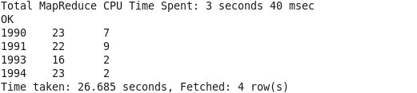

**Problem Statement :4**

Create a view on the top of last query, name it temperature_data_vw.

Ans:

Create view temperature_data_vw as

SELECT YEAR(cast(to_date(from_unixtime(unix_timestamp(tdate, 'dd-MM-yyyy'))) as date)) Temp_date ,MAX(temp),

COUNT(YEAR(cast(to_date(from_unixtime(unix_timestamp(tdate, 'dd-MM-yyyy'))) as date)))

FROM temperature

GROUP BY YEAR(cast(to_date(from_unixtime(unix_timestamp(tdate, 'dd-MM-yyyy'))) as date))

Having COUNT(YEAR(cast(to_date(from_unixtime(unix_timestamp(tdate, 'dd-MM-yyyy'))) as date))) >=2;

Describe temperature_data_vw;

Select * from temperature_data_vw;